 | THE WINCHESTER AND PORTSMOUTH DIOCESAN  GUILD OF CHURCH BELL RINGERS  Founded 20th June 1879 as the Winchester Diocesan Guild  Presidents: THE RIGHT REVD THE LORD BISHOP OF WINCHESTER  THE RIGHT REVD THE LORD BISHOP OF PORTSMOUTH | 
NEW GUILD SWEATSHIRTS AND POLO SHIRTS – 2024


With the spread of covid and the restriction of ringing largely behind us, plus the welcome influx of new ringers throughout the Guild this would seem to be an opportune time to put in another order for Guild sweatshirts and polo shirts. The details are shown below. Sadly prices have risen this time but, we feel, are still competitive. Each one has the Guild logo (red, white and blue sally, with W&P in gold, 3” by 1½”) on the left breast. If you would like to place an order, please complete the relevant section(s) of the form and return this to Christine Knights-Whittome, 3 Oaklands, South Wonston, Winchester, SO21 3HZ by Tuesday 26th March 2024. This will enable the order to be placed before 1st April, with delivery in May, in time for the Guild AGM.

Either: Send your form to Christine with a cheque for the total amount (including any necessary
postage) made out to the Winchester and Portsmouth Guild,
Or: Submit your form to Christine by email christine.kwhittome@gmail.com and forward
the total amount direct to the Guild’s bank account, using the reference Sw.P.2024
(Account name: Winchester & Portsmouth Guild, Account no; 00040255, Sort code:
30 97 80). Please make sure your name is also included so the Guild Treasurer knows
where the payment has come from.
When the garments have been received I will contact you to arrange collection/delivery. Post and packing, if required, would be extra – 1st Class £4.74, 2nd Class £4.04 per garment.

Your name: PLEASE PRINT CLEARLY

Your address:

Contact phone number: | Home Tower:
Your email:


SWEATSHIRTS - £17.50 each
Raglan sleeve, 80% cotton 20% polyester.
Colours: *Black, White, Navy, Royal Blue, Red, Purple (not XXL), Kelly (bright green), Bottle Green, Burgundy (not XXL), Heather Grey.
Sizes: S (35/37”), M (38/40”), L (41/42”), XL (44/46”), XXL (47/49”). *Black only is also available in 3XL (50/52”) and 4XL (53/55”)
How many | Size | Colour | Cost | Total Amount
 |  |  | £17.50
 |  |  | £17.50
 |  |  | £17,50
 |  |  | £17,50
 |  |  | £17.50
 |  |  | £17.50
Please turn over ………..

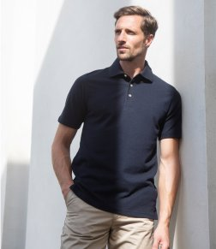
MEN’S POLO SHIRTS - £16.50 each
Straight-sided, 100% cotton, stand up collar, set-in sleeve, three horn-button placket, side vents, twin-needle stitching.
Colours: Black, White, Navy, Royal Blue, Bottle Green, Heather Grey, Purple
Sizes: XS (34/36”, (only available in black, white and navy), S (36/38”),
M (38/40”), L (42”/43), XL (44/46”), XXL (47/49”)

How many | Size | Colour | Cost | Total Amount
 |  |  | £16.50
 |  |  | £16.50
 |  |  | £16.50
 |  |  | £16.50
 |  |  | £16.50
 |  |  | £16.50


LADIES’ POLO SHIRTS - £16.50. each
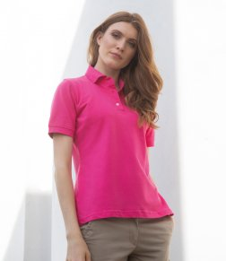
Slightly shaped sides, 100% cotton, set-in sleeves, stand-up collar, three pearlised-button placket, ribbed cuffs, taped side-vents.
Colours: Black, White, Navy.
Sizes: 10 (32/34”), 12 (34/36”), 14 (36/38”), 16 (38/40”), 18 (40/42”)

How many | Size | Colour | Cost | Total Amount
 |  |  | £16.50
 |  |  | £16.50
 |  |  | £16.50
 |  |  | £16.50
 |  |  | £16.50
 |  |  | £16.50

SOMETHING EXTRA!
If you already have a favourite garment – be it polo shirt, sweatshirt, fleece, jacket, almost anything – the Guild logo can be added to this for £4.00 Please contact Christine for details.

IMPORTANT – PLEASE NOTE
Once the order has been completed you can’t change your mind! It is not like a shop where you can return things (unless, of course, they are faulty), so if you have ANY queries at all please talk to Christine BEFORE YOU ORDER.

Tel: 01962 886939 email: christine.kwhittome@gmail.com

